**SQL query - 1**

**Send Feedback**

**Problem Statement:**  
Write a SQL query to find out the quantity supplied by anjali and rachit.

**Information about the table:**  
Table **Product**:  
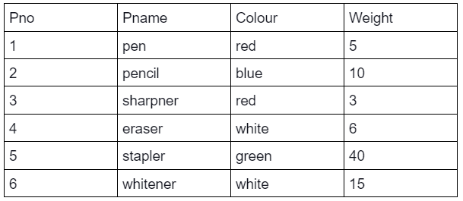  
Table **Supplier**:  
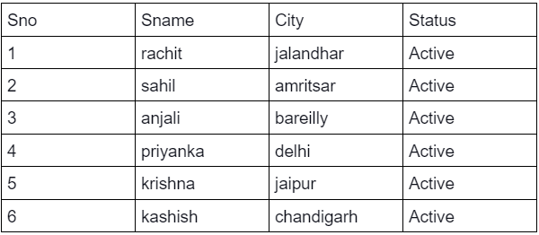  
Table **SP**:  
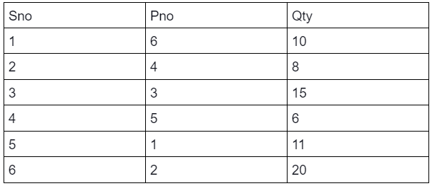

**Output Table Structure:**  


Note: Write keywords of syntax in uppercase alphabets.

+------+

| Qty |

+------+

| 10 |

| 15 |

+------+

Select Qty from SP where sno in (Select sno from Supplier where sname in ('anjali','rachit'));

**SQL query - 2**

**Send Feedback**

**Problem Statement:**  
Write a SQL query to display the supplier name and city of the supplier who supplies parts with Pno 1 and 5.

**Information about the table:**  
Table **Product**:  
  
Table **Supplier**:  
  
Table **SP**:  


**Output Table Structure:**  


#### Note: Write keywords of syntax in uppercase alphabets.

+----------+--------+

| Sname | City |

+----------+--------+

| priyanka | delhi |

| krishna | jaipur |

+----------+--------+

SELECT Sname,City from Supplier where Sno in (SELECT Sno from SP where Pno in (1,5));

**SQL query - 3**

**Send Feedback**

**Problem Statement:**  
Write a SQL Query to get the colour of parts supplied by Supplier with Sno 1,3,6

**Information about the table:**  
Table **Product**:  
  
Table **Supplier**:  
  
Table **SP**:  


**Output Table Structure:**  


#### Note: Write keywords of syntax in uppercase alphabets.

+--------+

| Colour |

+--------+

| blue |

| red |

| white |

+--------+

SELECT Colour from Product where Pno in (SELECT Pno from SP where Sno in (1,3,6));

**SQL query - 4**

**Send Feedback**

**Problem Statement:**  
Write a SQL query to get the colour of parts supplied by all the employees except rachit and kashish.

**Information about the table:**  
Table **Product**:  
  
Table **Supplier**:  
  
Table **SP**:  


**Output Table Structure:**  


#### Note: Write keywords of syntax in uppercase alphabets.

+--------+

| Colour |

+--------+

| red |

| red |

| white |

| green |

+--------+

SELECT Colour from Product where Pno in (Select Pno from SP where Sno in (Select Sno from Supplier where Sname not in ('rachit','Kashish')));

**SQL query - 5**

**Send Feedback**

**Problem Statement:**  
Print the name and age of all oldest sailors.

**Information about the table:**  
Table **sailors:**:  
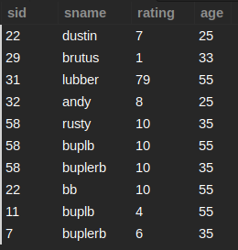  
Table **boats**:  
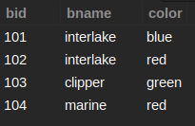  
Table **reserves**:  
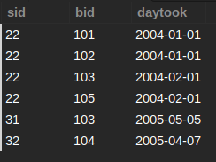

**Output Table Structure:**  


#### Note-1: There can be multiple sailors of the same age. All the sailors who are the oldest should be listed in the output.

#### Note-2: Write keywords of syntax in uppercase alphabets.

+--------+------+

| sname | age |

+--------+------+

| lubber | 55 |

| buplb | 55 |

| bb | 55 |

| buplb | 55 |

+--------+------+

Select sname,age from sailors where age > (Select avg(age) from sailors);

**SQL query - 6**

**Send Feedback**

**Problem Statement:**  
Write a SQL Query to get the supplier name who supply pencils with quantity greater than 10.

**Information about the table:**  
Table **Product**:  
  
Table **Supplier**:  
  
Table **SP**:  


**Output Table Structure:**  


#### Note-1: Write keywords of syntax in uppercase alphabets.

#### Note-2: Remember that the column values are case-sensitive.

+---------+

| Sname |

+---------+

| kashish |

+---------+

Select Sname from Supplier where Sno in

(Select Sno from SP where Pno in (SELECT Pno from Product where Pname = 'pencil') and Qty > 10 );

**SQL query - 7**

**Send Feedback**

**Problem Statement:**  
List down all the Employees whose salary is greater than that of Monica Geller.

**Information about the table:**  
Table **Employee**:  
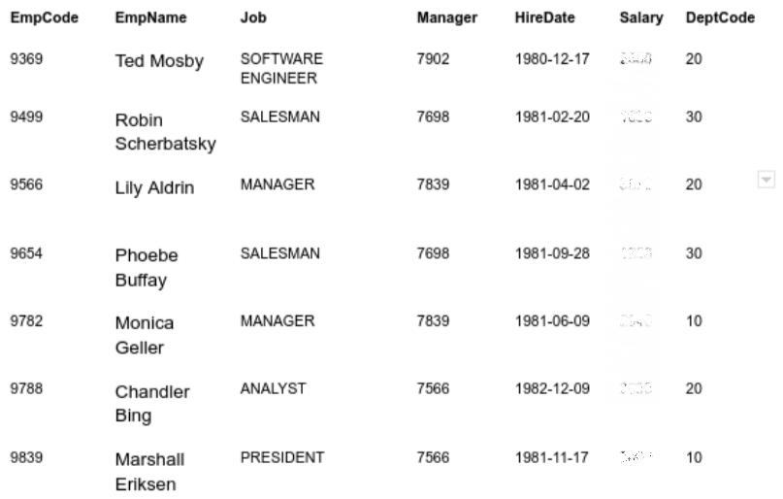

**Output Table Structure:**  


#### Note-1: Write keywords of syntax in uppercase alphabets.

#### Note-2 : You are not authorized to view the salaries of the employees.

+------------------+

| EmpName |

+------------------+

| Lily Aldrin |

| Chandler Bing |

| Marshall Eriksen |

+------------------+

SELECT EmpName from Employee where Salary > (Select Salary from Employee where EmpName='Monica Geller');

**SQL query - 8**

**Send Feedback**

**Problem Statement:**  
List down all the employees whose job is the same as Phoebe Buffay.

**Information about the table:**  
Table **Employee**:  
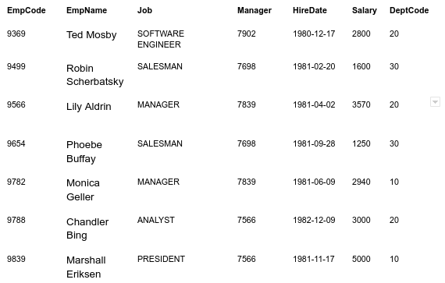

**Output Table Structure:**  


#### Note: Write keywords of syntax in uppercase alphabets.

+-------------------+--------+----------+----------+

| EmpName | Salary | DeptCode | Job |

+-------------------+--------+----------+----------+

| Robin Scherbatsky | 1600 | 30 | SALESMAN |

| Phoebe Buffay | 1250 | 30 | SALESMAN |

+-------------------+--------+----------+----------+

Select EmpName,Salary,DeptCode,Job From Employee

where job = (Select Job from Employee where EmpName = 'Phoebe Buffay');

**Sub query - 9**

**Send Feedback**

**Problem Statement:**  
Print out all the employees with their respective Departments if there is at least one employee whose salary is more than 4000.

**Information about the table:**

Table **Employee**:  


**Output Table Structure:**  


#### Hint: use EXISTS operator.

#### Note: Write keywords of syntax in uppercase alphabets.

+-------------------+----------+

| EmpName | DeptCode |

+-------------------+----------+

| Ted Mosby | 20 |

| Robin Scherbatsky | 30 |

| Lily Aldrin | 20 |

| Phoebe Buffay | 30 |

| Monica Geller | 10 |

| Chandler Bing | 20 |

| Marshall Eriksen | 10 |

+-------------------+----------+

Select EmpName,DeptCode from Employee where exists (Select * from Employee where Salary > 4000);

**SQL query - 10**

**Send Feedback**

**Problem Statement:**  
Find the name of boats and their respective colors of the sailors with minimum age.

**Information about the table:**  
Table **sailors:**:  
  
Table **boats**:  
  
Table **reserves**:  


**Output Table Structure:**  


#### Note-1: All the sailors who are youngest should be listed in the output.

#### Note-2: Write keywords of syntax in uppercase alphabets.

+-----------+-------+

| bname | color |

+-----------+-------+

| interlake | blue |

| interlake | red |

| clipper | green |

| marine | red |

+-----------+-------+

SELECT bname,color from boats where bid in (Select bid from reserves where sid in (

Select sid from sailors where age = (

Select min(age) from sailors)));

**SQL query - 11**

**Send Feedback**

**Problem Statement:**  
Find the IDs of sailors and their daytook for sailors with highest rating.

**Information about the table:**  
Table **sailors:**:  
  
Table **boats**:  
  
Table **reserves**:  


**Output Table Structure:**  


#### Note: Write keywords of syntax in uppercase alphabets.

+------+------------+

| sid | daytook |

+------+------------+

| 31 | 2005-05-05 |

+------+------------+

SELECT sid,daytook from reserves where sid in (Select sid from sailors where rating =

(Select max(rating) from sailors));

**SQL query - 12**

**Send Feedback**

**Problem Statement:**  
Write a SQL query for the red-colored products whose original weight is less than 10 units; displaying information in the output table as: product name, colour and 20 times the original weight as 'w'.

**Information about the table:**  
Table **Product**:  
  
Table **Supplier**:  
  
Table **SP**:  


**Output Table Structure:**  


#### Note: Write keywords of syntax in uppercase alphabets.

+----------+--------+------+

| Pname | Colour | w |

+----------+--------+------+

| pen | red | 100 |

| sharpner | red | 60 |

+----------+--------+------+

Select Pname,colour,20*Weight as w from (Select * from Product where Weight < 10 and Colour = 'red') as temp;

**SQL query - 13**

**Send Feedback**

**Problem Statement:**  
List down the employee details with their annual salary, given that the annual salary of the employees being listed should be greater than 30000

**Information about the table:**  
Table **Employee**:  


**Output Table Structure:**  


#### Note: Write keywords of syntax in uppercase alphabets.

+---------+------------------+--------+-------+

| EmpCode | EmpName | Salary | A_Sal |

+---------+------------------+--------+-------+

| 9369 | Ted Mosby | 2800 | 33600 |

| 9566 | Lily Aldrin | 3570 | 42840 |

| 9782 | Monica Geller | 2940 | 35280 |

| 9788 | Chandler Bing | 3000 | 36000 |

| 9839 | Marshall Eriksen | 5000 | 60000 |

+---------+------------------+--------+-------+

Select EmpCode,EmpName,Salary,salary*12 as A_Sal from Employee where salary*12 > 30000;

**SQL query - 14**

**Send Feedback**

**Problem Statement:**  
Print the employee details for all employees who earn more than the average salary and having an “e” in their name.

**Information about the table:**  
Table **Employee**:  


**Output Table Structure:**  


#### Note: Write keywords of syntax in uppercase alphabets.

+---------+------------------+--------+

| EmpCode | EmpName | Salary |

+---------+------------------+--------+

| 9369 | Ted Mosby | 2800 |

| 9566 | Lily Aldrin | 3570 |

| 9782 | Monica Geller | 2940 |

| 9788 | Chandler Bing | 3000 |

| 9839 | Marshall Eriksen | 5000 |

+---------+------------------+--------+

Select EmpCode,EmpName,Salary from Employee e where salary > (

Select avg(salary) from Employee where e.EmpName like '%e%');

**SQL query - 15**

**Send Feedback**

**Problem Statement:**  
Find the ids and names of sailors who have reserved at least two different boats.

**Information about the table:**  
Table **sailors:**:  
  
Table **boats**:  
  
Table **reserves**:  


**Output Table Structure:**  


#### Note: Write keywords of syntax in uppercase alphabets.

+------+--------+

| sid | sname |

+------+--------+

| 22 | dustin |

| 22 | bb |

+------+--------+

Select sid,sname from sailors s where sid in

(Select s.sid from sailors s,reserves r, boats b

where s.sid = r.sid and b. bid = r.bid

group by s.sid having count(b.bid)>1);

**SQL query - 16**

**Send Feedback**

**Problem Statement:**  
Fetch out the color, sailor id and boat id of the boats reserved by the Sailor having 2nd highest rating.

**Information about the table:**  
Table **sailors:**:  
  
Table **boats**:  
  
Table **reserves**:  


**Output Table Structure:**  


#### Note: Write keywords of syntax in uppercase alphabets.

Select b.color,s.sid,b.bid from sailors s,boats b,reserves r where s.sid = r.sid and r.bid = b.bid and s.rating in

(Select max(rating) from sailors where rating not in

(Select max(s.rating) from sailors s));

+-------+------+------+

| color | sid | bid |

+-------+------+------+

| green | 22 | 103 |

| red | 22 | 102 |

| blue | 22 | 101 |

+-------+------+------+

**SQL query - 17**

**Send Feedback**

**Problem Statement:**  
Display all the sailor id, boat id and sailor name which are reserved by Sailors who have ratings more than the average rating in the reserves table.

**Information about the table:**  
Table **sailors:**:  
  
Table **boats**:  
  
Table **reserves**:  


**Output Table Structure:**  


#### Note-1: The order of display should be same as mentioned in the question.

#### Note-2: Write keywords of syntax in uppercase alphabets.

SELECT r.sid,r.bid,s.sname from sailors s,reserves r where s.sid = r.sid and

s.rating >

(Select avg(rating) from sailors join reserves on s.sid = r.sid);

+------+------+--------+

| sid | bid | sname |

+------+------+--------+

| 31 | 103 | lubber |

+------+------+--------+

**SQL query - 18**

**Send Feedback**

**Problem Statement:**  
Display all the sailor id, boat id, sailor name and boat color which are reserved by Sailors who have ratings less than the average rating in the reserves table.

**Information about the table:**  
Table **sailors:**:  
  
Table **boats**:  
  
Table **reserves**:  


**Output Table Structure:**  


#### Note: Write keywords of syntax in uppercase alphabets.

+------+------+--------+-------+

| sid | bid | sname | color |

+------+------+--------+-------+

| 22 | 103 | dustin | green |

| 22 | 102 | dustin | red |

| 22 | 101 | dustin | blue |

| 32 | 104 | andy | red |

| 22 | 103 | bb | green |

| 22 | 102 | bb | red |

| 22 | 101 | bb | blue |

+------+------+--------+-------+

SELECT r.sid,r.bid,s.sname,b.color from sailors s,reserves r,boats b where s.sid = r.sid and r.bid = b.bid and

s.rating <

(Select avg(rating) from sailors join reserves on s.sid = r.sid);